# Sensing IR Pulses emitted from a mineral sample

A. Ng

## **Introduction**

One signal we must analyse from the rock samples is the presence of an infrared pulse, emitted from two of the six samples: netherite and thiotimoline. Pulses are emitted from the minerals at 571 and 353 Hz respectively. We must devise a system that will detect the pulses as well as identify the frequency at which the pulses are transmitted. Our solution should be minimal, occupying as little space as possible since we intend our rover to be lightweight and reliably detect infrared pulses.

## **What is a phototransistor and how could it be implemented in this project?**

Phototransistors are semiconductor devices**1** that comprise the same structure as the bipolar junction transistor (BJT), a three region semiconductor sandwich of two differently doped semiconductors. These regions are called the collector, base, and emitter where the collector and emitter are the same types of a doped semiconductor, while the base is the other type. Combining two differently doped semiconductors forms a PN diode, thus creating the junction between the base-emitter and base-collector. The difference between the BJT and the phototransistor is the lack of a base terminal pin for the phototransistor. Rather than supplying a current into the base, as we would for a BJT, the phototransistor generates this current internally – this is achieved by having the base region exposed and allowing light to reach this region.

Electromagnetic radiation (EM) such as visible and infrared, can fall onto the exposed region of the PN diode and can generate a current in the base region. All EM radiation has energy associated with them; this is defined by the Planck relation or more well-known as E = hf, where E denotes the energy of the photon, h is the Planck’s constant and f is the frequency of the EM radiation. If the energy incident on the PN diode is greater than the bandgap of silicon, 1.12 eV**2**, electron-hole pairs are produced in the PN diode, and the flow of these carriers generates a current in the phototransistor thus allowing conduction. Using the Planck relation, the frequency of the EM radiation needs to be greater than 2.703x1014 Hz. Inspection**3** of the EM spectrum shows that infrared and visible light have frequencies above this threshold and allow the phototransistor to conduct.

This property allows us to use a phototransistor to detect an infrared pulse transmitted by the samples, an input to a circuit that could analyse the conduction/current from the phototransistor and identify the frequency of the IR pulse.

## **Developing a solution**

Previously we encountered the phototransistor in the spring term lab skills to allow our EEE Bug to sense light therefore we could use a similar circuit for detecting the infrared pulses. A proposed circuit for analysing the nature of the emitted pulse is shown in fig. 1.

The circuit configuration represented in fig. 1 is of a photodarlington pair**4** where one transistor is a BJT, and the other is a phototransistor. The emitter of the phototransistor is connected to the base of the BJT with the effect of an increased current gain. The current at the emitter of the photodarlington pair is passed through an emitter resistor, which we measure the voltage across it as the digital input for the Adafruit board.

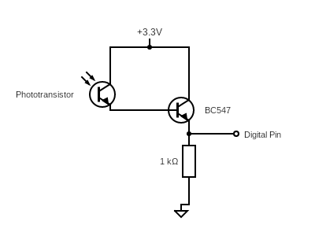

*Fig. 1: A circuit to analyse the nature of the infrared pulses emitted by the exorock.*

A 3.3V voltage supply was used as opposed to 5V because the logic level of the Adafruit board is 3.3V so using any voltage greater than this would damage the voltage regulator components on the board.

The signal was measured using the Arduino serial plotter software, which reads the digital input voltage from the circuit in fig. 1 and plots the values of the input as either high or low. The same code for the analogue-to-digital conversion (ADC) task in lab skills was used to plot the digital input readings with both infrared modes of the exorock tested, where results are shown in fig. 2.

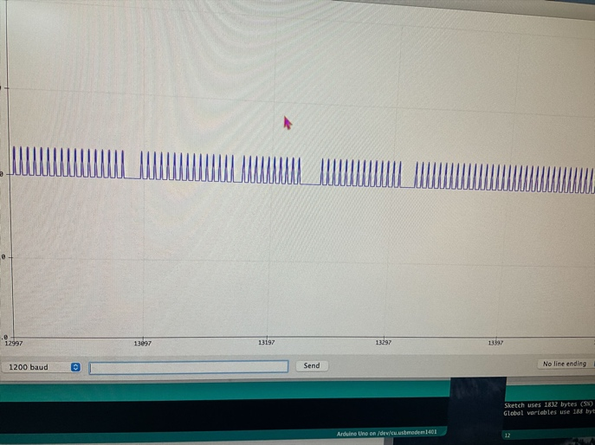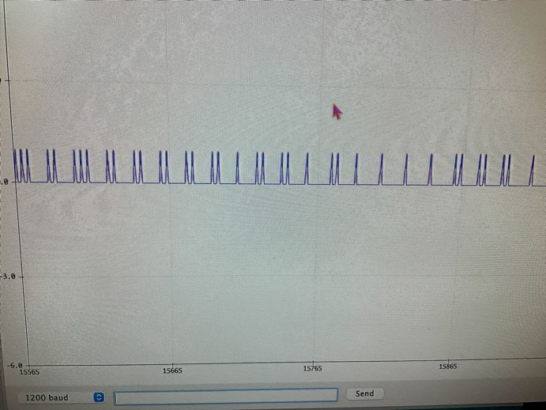

*Fig. 2: Arduino serial plotter readings from pulses of infrared of frequency 571 Hz (left) and 353 Hz (right).*

Viewing fig. 2 shows the digital pulsed signals received by the Adafruit board. The emitted pulses should maintain a constant distance between them to maintain their frequencies however we do not see this; pulses are inconsistent at 353 Hz but better for 571 Hz. Interference from other sources of infrared and visible could hinder the accuracy of readings therefore filtering the input was attempted. First-order high and low pass filters were implemented at the emitter of the photodarlington pair with corner frequencies at 353 and 571 Hz but provided unexpected results. Despite filtering out signals less than 353 Hz and signals greater than 571 Hz, the serial plotter software picked up pulses without the exorock being in infrared mode – this meant there were still interfering ambient signals that would be removed to determine the pulse frequency accurately.

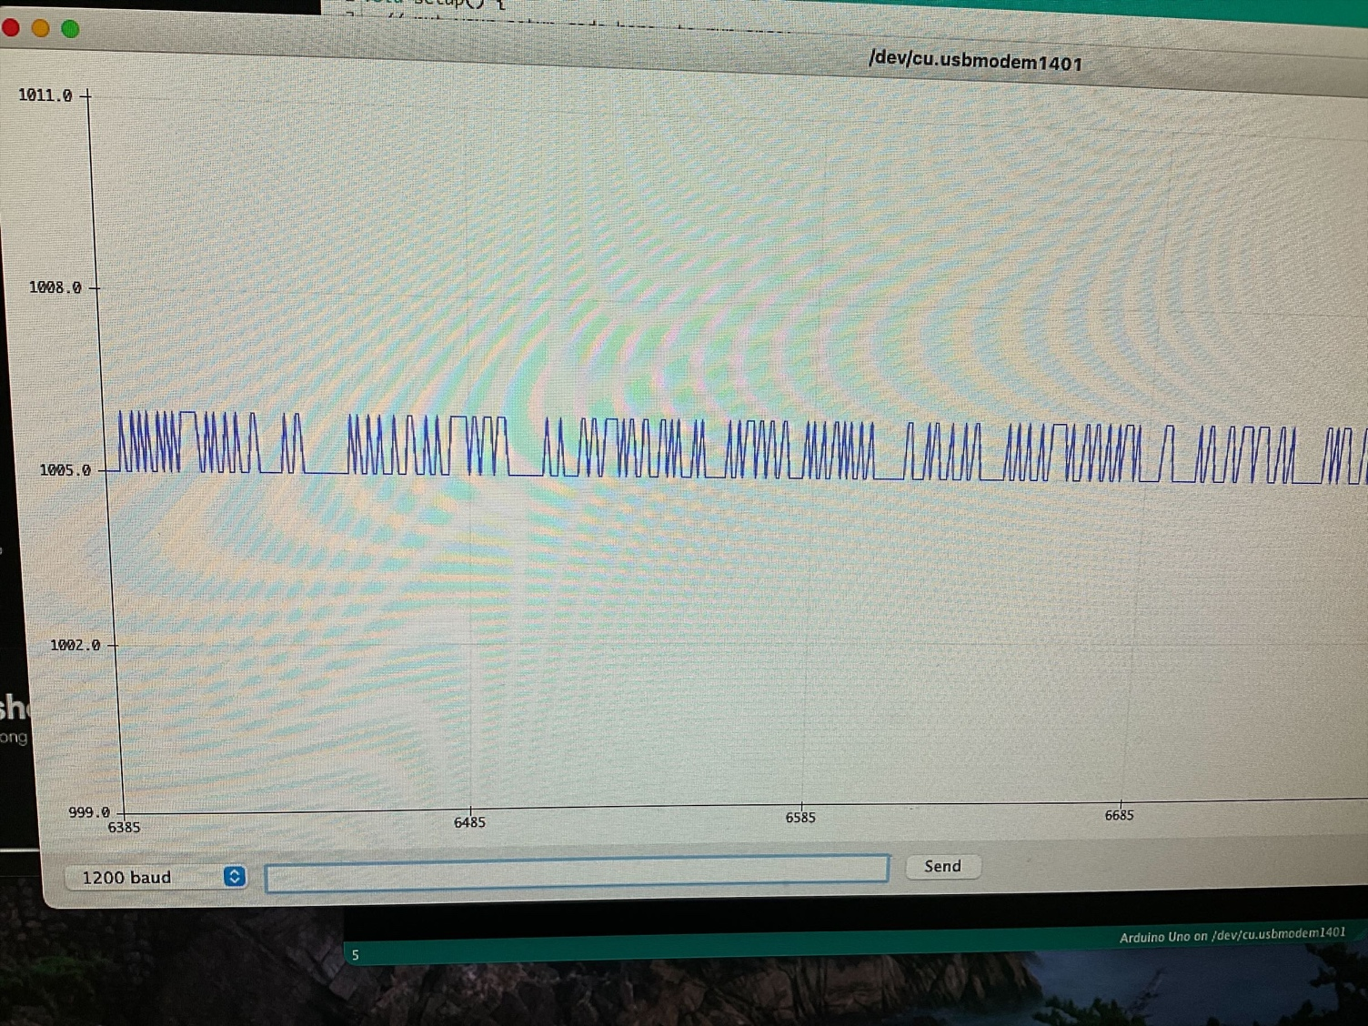

*Fig. 3: Arduino serial plotter readings with no infrared pulses directed at phototransistor. Pulses are a result of ambient signals incident on the phototransistor although a bandpass filter was applied to remove signals outside the pulse frequency.*

Also, visible light in the test environment hindered results as this would cause the digital reading in the serial plotter software to be pinned at a “high” and prevented peaks from being displayed. This presented a problem: “how do we remove the effects of visible light on the phototransistor but maintain the effects of infrared?”. Another issue was observed with the circuit in fig. 1 – these readings were measured with the shell of the exorock removed. When placing the exorock shell onto the exorock test board, there was no signal detected and this was checked using the picoscope software. The detected signal was noisy, displaying a pulse with a minimal amplitude; now an amplifier circuit would need to be designed to amplify the signal at the emitter of the photodarlington pair.

## **Refinements**

Preventing interference from visible light could be achieved in one of two ways: using an infrared phototransistor or 3D printing a custom cover for the phototransistor. Purchasing an infrared phototransistor was what we went for because 3D printing a custom cover would add more weight to the EEE Rover to cover the phototransistor compared to exchanging the existing phototransistor with an infrared phototransistor. The infrared phototransistor we purchased was the SFH 309 FA-4/5 ams OSRAM, with each unit costing £0.38. This was an NPN phototransistor, featuring a black plastic cover that blocked visible light signals from reaching the base but didn’t affect the performance of infrared signals.

Improvements introduced by using the infrared phototransistor were analysed using the same circuit as in fig. 1 but with the phototransistor component replaced with the infrared phototransistor. The detected signal is shown in fig. 4.

Viewing fig. 4 shows the nature of the pulsed signal as a square wave. The pulse frequency shown is 567.4 Hz, which would correspond to the 571 Hz infrared pulse mode on the exorock. The readings from the updated configuration was unaffected by visible light sources, making our signal more resistant to interference.

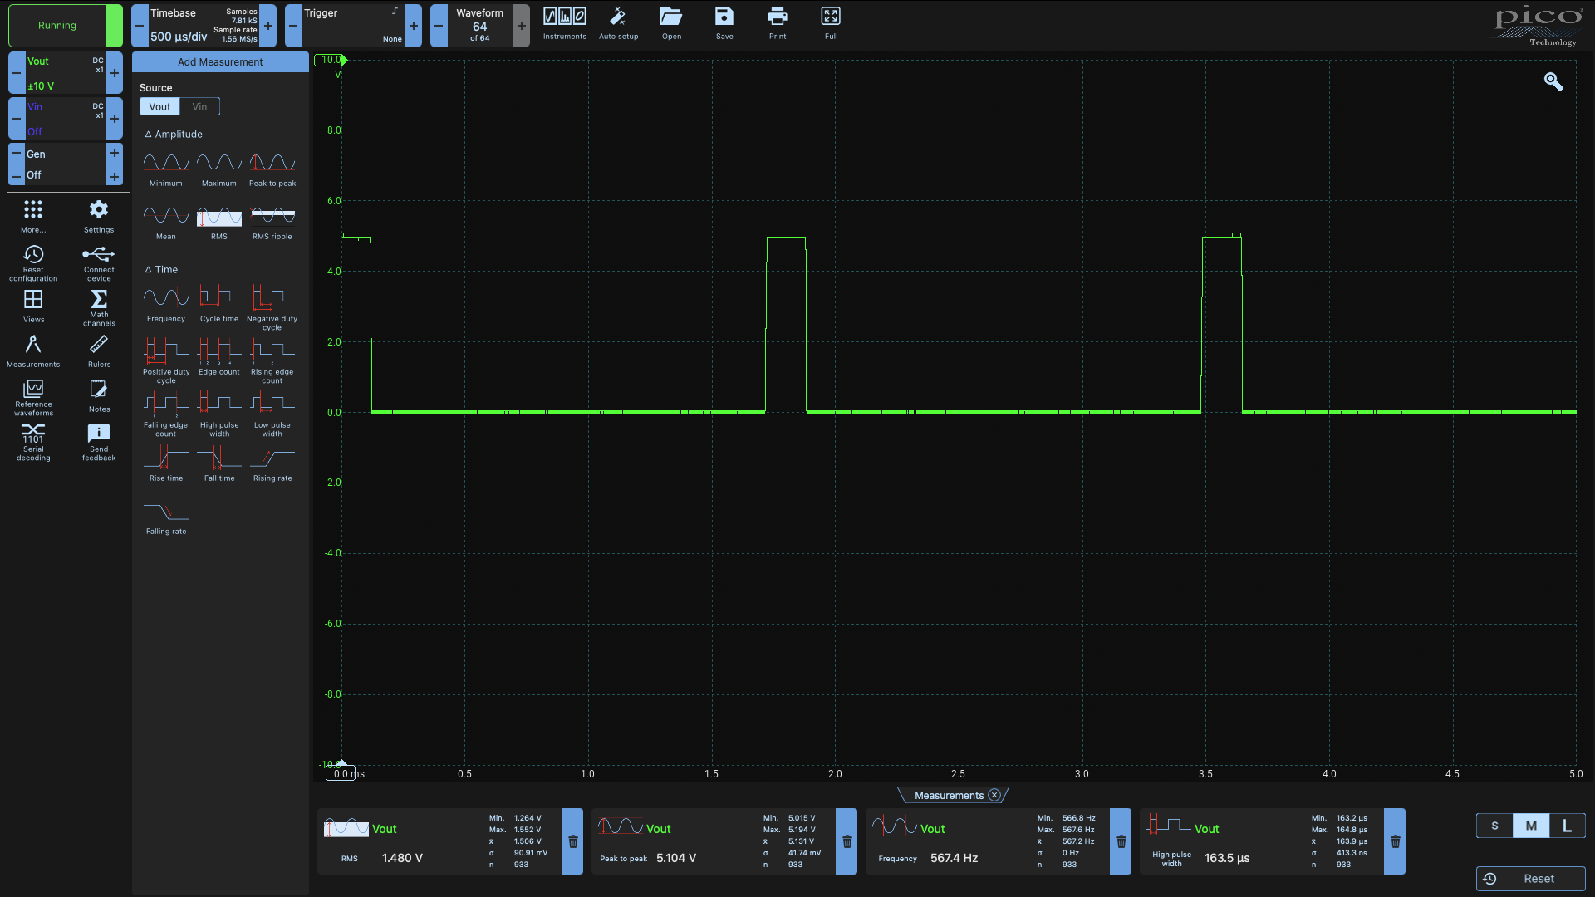

*Fig. 4: Infrared pulse signals read from the exorock board without the shell using the infrared phototransistor.*

Another issue we encountered was the weak signal perceived by the circuit when the exorock shell was placed on to the exorock board – the pulsed signal was present however at a low amplitude amongst the noise of the signal, so we need to amplify and filter the signal to remove low and high frequency noise.

## **Assessing the performance of our solution**

## **Processing the data and reviewing the outcome**

## **References:**

1. Circuit Globe. Phototransistor [Internet]. Circuit Globe; n.d. [cited 2022 May 30]. Available from: <https://circuitglobe.com/phototransistor.html>

2. Toshiba Electronic Devices & Storage Corporation. What is a wide-band-gap semiconductor? [Internet]. Toshiba Electronic Devices & Storage Corporation; n.d. [cited 2022 May 17]. Available from: <https://toshiba.semicon-storage.com/eu/semiconductor/knowledge/faq/diode_sic-sbd/sic-sbd001.html>

3. Phet University of Colorado. The EM Spectrum [Internet]. Phet University of Colorado; n.d. [cited 2022 May 17]. Available from: <http://labman.phys.utk.edu/phys222core/modules/m6/The%20EM%20spectrum.html>

4. Electronics Notes. Photodarlington [Internet]. Electronics Notes; n.d. [cited 2022 May 17]. Available from: <https://www.electronics-notes.com/articles/electronic_components/transistor/what-is-a-photodarlington.php>